At National Cathedral, LGBT Christians celebrate Supreme Court decision with prayer
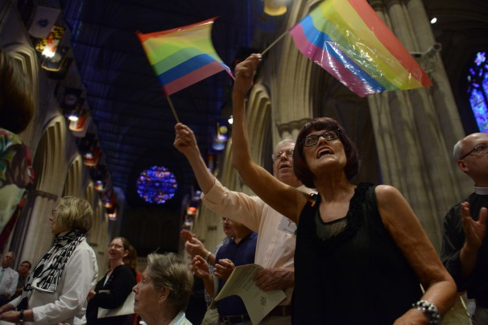

Jahi Chikwendiu/WASHINGTON POST - On the day the U.S. Supreme Court struck down the Defense of Marriage Act (DOMA), Beth Pattison, front right, and husband John Pattison, wave rainbow flags during a prayer service for the Lesbian Gay Bisexual Transgender community to mark the Supreme Court's ruling at the National Cathedral on Wednesday, June 26, 2013, in Washington.

By Julie Zauzmer, Published: June 27 E-mail the writer
The words of Scripture have been used time and again to preach against homosexual unions. But on Wednesday evening at the National Cathedral, the celebrants who sang “alleluia” as a Bible was held high found new meaning in its verses.

They prayed in the words of the prophet Isaiah, who spoke of a God who “strengthens the powerless.”
They prayed in the words of the Epistle to the Ephesians, which tells of an eternal sovereign for “every family in heaven . . . rooted and grounded in love.”
And they offered, perhaps, a new prayer — they thanked God and, in the same breath, they thanked the Supreme Court.
A few hundred joyful congregants gathered after Wednesday’s landmark Supreme Court decision that guaranteed federal benefits to married same-sex couples for a service of thanksgiving at the National Cathedral, where the Rev. Gary Hall has been a vocal supporter of same-sex marriage. In a separate case, the court opened the way for same-sex unions to resume in California.
“I do believe we have turned a corner in American life. I do believe we have turned a corner in the faith community’s life,” Hall said during the service.
He spoke of the Church’s historical views on marriage, recalling that in the past, Christians supported polygamy, and then believed that women should be subordinate to their husbands.
“We are now at a place where we are beginning to see together that the sacrament of marriage is a divine gift, a divine gift offered to everyone regardless of sexual orientation,” Hall said.
The National Cathedral, the seat of the Episcopal Church, began performing same-sex marriages in January, just months after Hall became the dean.
Aaron Elliott and Frank Piotrkowski, who are engaged to be married, said that many of their friends went to gay bars Wednesday night to hail the court’s decision. But they decided to go to church.
“I gave up on religion for a long time,” Elliott said. But when he found the congregation at the National Cathedral, though, he returned to the flock. “I felt like I can be a part of a religious community again, not be ostracized because of someone else’s ideas.”
Erin Hawkins and Anne Showalter, who were married last month in an Episcopal church, also praised the denomination for welcoming gay Christians.
“This has been a really important place for us to come back to the faith community,” Hawkins said. When she and her wife wanted to celebrate Wednesday’s ruling, they went to the National Cathedral. “It seemed like the right place to be.”
Both described the service — with a purple-robed choir, the sound of the organ pulsing to the heavenly ceilings of the vaulted nave, the setting sun seeping in through the stained glass windows, and a few plastic rainbow pride flags waving in the congregation — as the culmination of a day steeped in emotion.
“I never thought that this was going to happen,” Hawkins said. “I think LGBT people spend a lot of time thinking they’re not going to have things. You sort of prepare yourself. All of a sudden, I have way more than I ever thought I would have.”
Showalter agreed. “Things seem to be happening so fast,” she said. “You have to pinch yourself sometimes. The law, the welcomeness across the board — personally, professionally, politically, things are happening.”

